Prelab Discussion Points

- What are our goals for the user? What skills/knowledge should they walk away with?
  - Examples: Learn basic VR mechanics, learn overview of the process, practice with certain in game mechanics, etc?
  - Are there any additional lab rules or safety reminders not included in the modules that we can include in the prelab?
The goals of the pre-lab room are for helping users to get familiar with the basic interactions as well as the essential mechanism that are present in the XR Cleanroom environment.

In terms of interactions, these could include, grabbing up a tweezer, holding a wafer, holding a wafer and moving around, interacting with the UI, interacting with the checklist, and so on.

In terms of mechanism/functions, these could include information center (e.g., tutorial video, progress bar, losing or earning points, AI agent), locomotion options.

I second everything said above.

- How much time should the prelab take to be most effective but not overwhelming?
  - How much time is most effective in terms of testing sessions running smoothly?
  - How much time is most effective in terms of user experience?
The idea of prelab is to help learners/users to be comfortably learn the subject content without being stressed about the VR operations. We can allow the learners/users to practice the VR interactions/operations until they are confident to move on to the learning. There is no time limit. From our previous experiences, we observed users practicing the operations in less than 10mins.

10 minutes is a good target for the prelab only. We need to keep in mind that we will eventually add PPE as well, which will push the pre-simulation segment up to around 20 minutes. Let’s keep it brief, but still cover all of our bases.

- How should the user be guided?
  - Should the prelab be self-led (the user can walk around and interact with things at their own pace and discretion)?
  - Should the user be guided (the user has limited freedom and is taken through every step in order)?
Both. Pre-lab should be self-paced; while we want to let them know, once they have completed practicing a set of interaction, they can move to the next one.
This is the part where I differ with Shangman a little bit. I think the prelab should be structured/modeled exactly after the RIE/Photolithography modules with a tutorial video and set of interaction steps. This will familiarize them with the simulation structure and the interactions simultaneously. We could even add a keybind quiz if we think that is necessary. I would keep it at one question and maybe just ask them which button they have to press to activate NOVA and provide them an diagram of both of the controllers.

- Should we include Nova AI?
  - How do we expect the user to interact with Nova in the prelab, and does this affect our implementation?
  - How should we implement Nova?
Yes, we should implement NOVA AI into the Pre-lab, as this is a key function/interaction that they will need to use in the official lab training area. Instructions about how to use NOVA AI should be provided with clarity.

Following along with the previous pre-lab, we could add a new practice task in the pre-lab room, which focusing on the “info center”. When introducing the “info center”, all the components in this center should be presented, which includes NOVA AI.

Yes, one of the steps should be asking NOVA a question. When being told to ask a question on the spot, the user might draw a blank, so we should provide them with an (optional) question prompt of asking “What is a cleanroom?” this way we don’t have to mess around with the logic of figuring out what they asked, but instead just make sure that a prompt was given to NOVA.

- How should our UI and interactions be set up visually?
  - Could we include a version of the info center, have floating videos next to the interactions, etc?
  - How should we lay out the room?

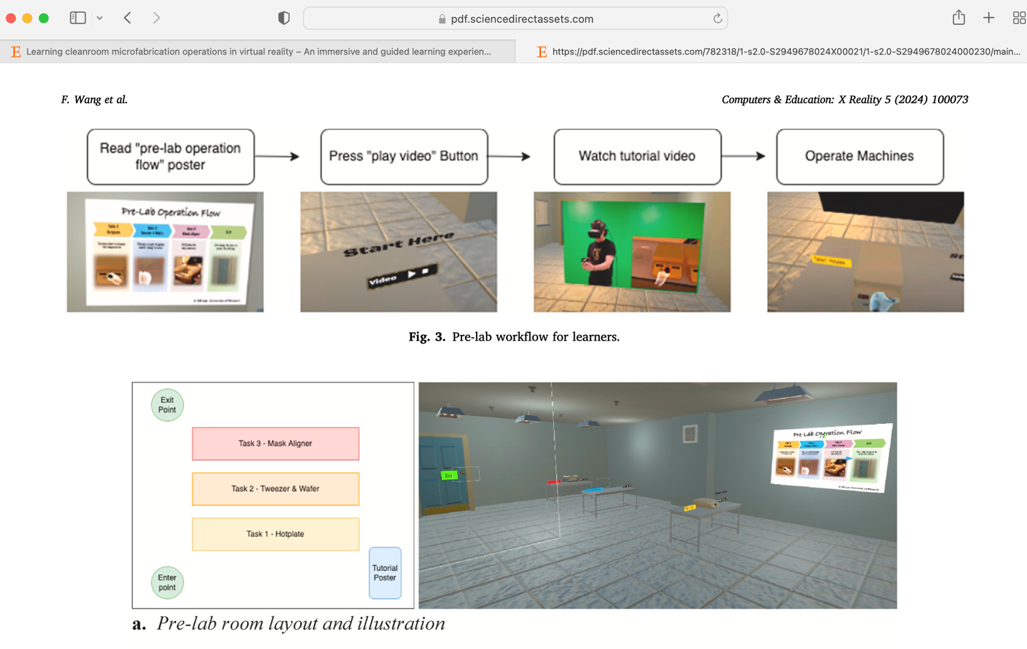
In the previous pre-lab, we have a total of four steps in this room (see screenshot below). Each step provides a short learning-by-doing chance for the users: 1) watch a short video, 2) practice it right away at their own paces. Similarly, when we include the tutorials of the info center, we need to think about the consistency. We could have a tutorial video talk about this info center, and have the learner/users to interact with the center.

Yes, include the info center. See me for a set of controller animations I worked on over the summer that we can include for extra assistance!

- What models do we expect to need at this point?
  - What objects from our other modules are necessary to include for our prelab interactions?
  - Do we anticipate needing any new models?

We need to include the essential operations/interactions, not necessarily the new objects. If the new object shares the same type of interaction mechanism with other objects, then, we do not need to include them in the pre-lab area. I would recommend categorizing all the interactions that are existed in the updated module first, then, plan the learning content in the pre-lab area. For example,

Interaction Types (below just examples) | Models (below just examples) | Pre-lab?
Grabbing | Door Knob;  Tweezer…… | Add plan here
Turning | Micrometers on mask-aligner…  Vault…. | Add plan here
Hold | Wafer…  Tweezer… | Add plan here
Movement/Locomotion | / | Add plan here
Point-and-click | Spinner UI Screen….  REU UI screen… | Add plan here

I personally think that there should be at least one interaction for each button they will have to use, with additional interactions for the specific interaction types they might find confusing.

Here is the revision I am thinking of, feel free to adjust it as needed!

Interaction Types (below just examples) | Models (below just examples) | Task
UI Poking | Info Center | Watch the Prelab tutorial video, answer a quiz question, and proceed with the steps.
Press B for NOVA | Info Center | Go to the NOVA tab, press B, and ask a question such as “What is a cleanroom?”
Looking (Right Joystick) | Player Rig | Use the right joystick to look at (x)
Moving (Left Joystick) | Player Right | Use the left joystick to walk to (x)
UI Poking for Locomotion Swap | Info Center | Switch the locomotion type and decide if you prefer gradual or teleport.
Mesh Poking (Switch flip) | Hot plate or Betta Industrial Heater Cooler | Turn on the machine by poking the power switch
Grabbing | Tweezers | Pick up the tweezers
Clicking/trigger | Wafer | Pick up the wafer with the tweezers
Multi hand grab | Wash bottle | Pick up the wash bottle with your left hand
Clicking/trigger | Wash bottle and waste bucket | Spray the wafer over the waste bucket
Turning | Oxygen tank knob, mask aligner dial, probably not the hot plate dial since we are still having sensitivity issues | Turn the knob clockwise or counterclockwise one full 360 degree rotation.
UI Point & Click | N/A | This may or may not be necessary since the only time they will need to use this is the on the main menu which they will have to use to get to the prelab section.

Summary: The tasks in the table are listed roughly in the order that they should be executed with the goal to center the tasks around one focus area at a time (ex. Focus on the info center, then locomotion, then the basics of grabbing/poking objects, then complex multi-button interactions, and turning a knob or dial.

9/3 Meeting we should discuss how to handle a self-guided component to the prelab.
I’m thinking have a clear line of tasks with focus areas as mentioned above, but they should be able to reset any of the practice interactions at any time to redo them if they wish without having to start the entire prelab over again.

